**Description**

For the project I have in mind, the overall concept is almost equal parts finding the right people for the job, and equal parts putting the gears in motion and doing a solid execution. Creating a game that is simple enough to be cut down to a mobile app, but also has the potential of taking us into the next semester and beyond, maybe even becoming a full-length indie title some day. Teaming up with people both skilled and driven enough to produce a beautiful teaser title for the first semester, and love what they do enough to see it through into the second semester, and even on into our professional lives.

The game being designed is using the basic concept of platforming and mixing it with a concept called flow field. A flow field is an area in space that applies external force upon an object in space, the simplest real life example being what happens to a leaf when caught by a gust of wind. It is my belief that flow mapping certain parts of a platformer will allow for some interesting and enjoyable play experiences, as well as an opportunity for visually striking situations. It will have audio, as well as hand crafted 2D animation.

The final result would look like a well-animated platformer video game, a tidbit of one, clearly displaying our focus on visual aesthetics. The deliverable at the end of this semester will take the form of a short (3 – 5 minutes of play) game, teasing some of the more promising aspects of its design.

My deliverables would include programming and procedural animation assets:

* Controllable character in a 2D environment.
* Working set of procedural animations on the character, particles, etc.
* Basic game mechanics, including platforming, and “flowing”
* A level builder program and other tools as we find we need them.
* Possible additional game mechanics, items, dialogue, cut scenes, etc.

I would also be willing to lead the charge and do what I can to train my fellow workers on the technologies they are unfamiliar with, like GitHub, and whatever programs I push out.

The ASUGDC has had members express a desire to journal about us and be play testers and may be dipped into for assets like level design, or even story writing. The game will feature audio engineered by DC’s Markus Renneman, and will be externally collaborative in any way the team deems fit. The more the merrier.

I am drawing my inspiration not only from childhood games like Sonic and Mario, but also from games coursing through our society today like Child of Light, Bastion, Dust, Braid, and Super Meat Boy. Also, let’s not forget the myriad Disney, or even Miyazaki films, the bazillion theory and tutorial web pages on ye old internet, books, and of course, the people who inspire and teach me in my life.

**Project Flow Diagram**

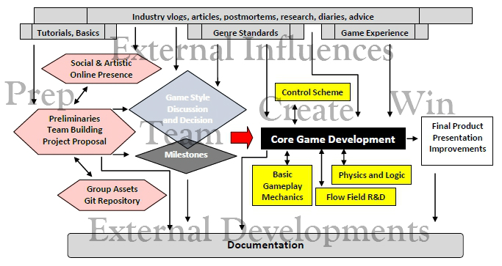

**Software: C#/XNA/Processing, Gimp/AdobeCS, Git/GitHub, created content**

**Hardware: Compute, Keyboard, Mouse, no arm cannon required**

**E:\Capstone\Sketch.jpg**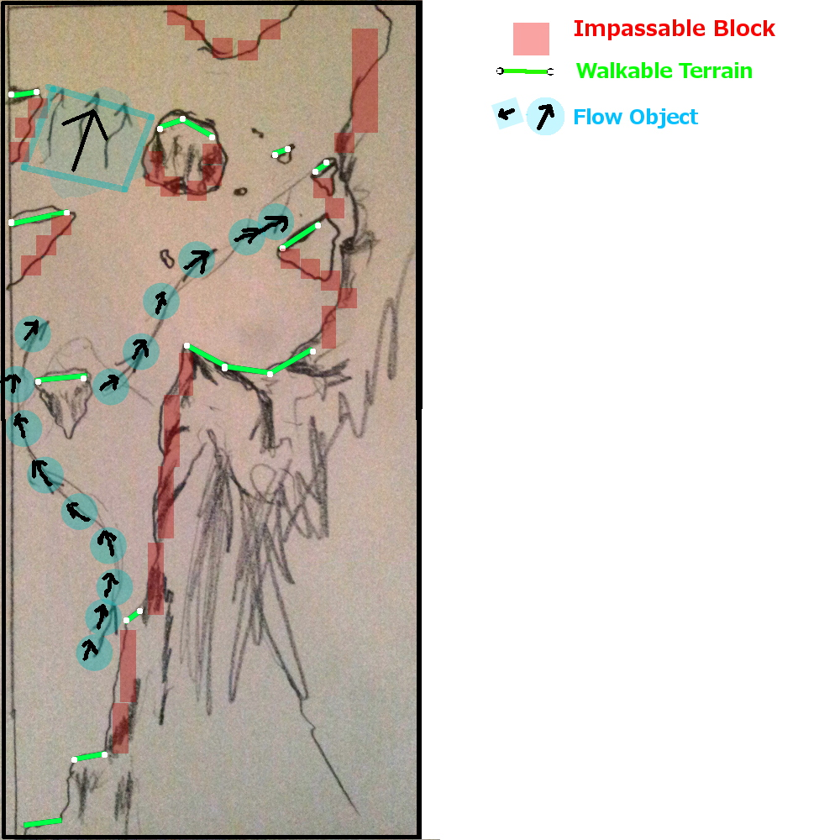

**This is an example of how sparse the platforming mechanic could be. Notice how small in number and size the platforms are. Flow fielding unlocks a completely different method of traversal.**

**Player path**

**Flow field representations will include semi-transparent animations, usually resembling a natural occurrence, that change the velocity of an object in their space.**

**Artist will be able supply their own art to work on top of, sculpting a level in a very organic fashion, using hand placed geometry, and a custom made set of tools. The flow objects shown to the right are geometry that applies force to other objects, such as the player, as they pass through.**

Example of daily work routine

**Simple Level Design Concept**

**Level Editor Concept**

**Building a level editor may seem like a lot of extra, unnecessary work, but being able to rapidly prototype game situations, as well as give the job of level design to a non-programmer can be invaluable.**

